Exercises: Data Formats
Exercise problems for the "Back-End Technologies Basics" Course @ SoftUni.

JSON

Books

Extract information and create a JSON
You are given a table of five books.
Each book has the following attributes: title (string), author (string), released (int), pages (int), ISBN (string).
Title | Author | Released | Pages | ISBN
In Search of Lost Time | Marcel Proust | 1913 | 4215 | 978-0-307-70075-2
Ulysses | James Joyce | 1922 | 730 | 978-0-679-72276-2
Pride and Prejudice | Jane Austen | 1813 | 432 | 978-1-85326-000-2
Moby Dick | Herman Melville | 1851 | 635 | 978-0-14-243724-7
Harry Potter and the Sorcerer's Stone | J.K. Rowling | 1997 | 309 | 978-0-590-35342-7
Convert the table of books data into a structured JSON format manually:
- Use a text or a code editor to write the JSON document. We recommend Notepad++ or VS Code.
- Extract relevant details from each book's description.
- Organize the data into a structured JSON format:
- Each book should be a separate object within an array.
- Include the following keys: title, author, released, pages, ISBN.
Example:
Books.json
[
{
"title": "In Search of Lost Time",
"author": "Marcel Proust",
"released": 1913,
"pages": 4215,
"ISBN": "978-0-307-70075-2"
},
{
"title": "Ulysses",
"author": "James Joyce",
"released": 1922,
"pages": 730,
"ISBN": "978-0-679-72276-2"
}
// ... other books ...
]

Use the Provided JSON Parser to Parse the Books
You are provided with a JSON parser application. Use it to parse and validate the JSON file you have created.
- Open the parser application using Visual Studio. This application is pre-configured to read JSON files from a specific directory.
- Within the parser project, locate the Datasets folder. You will find empty Books.json file here.
- Open the existing Books.json file.
- Replace the content of Books.json with the JSON data you created.
- After pasting your JSON data into the coresponding JSON file, make sure to save any changes.
- Run the parser application within your IDE.
- The application will ask you which file you would like to use. Type books.
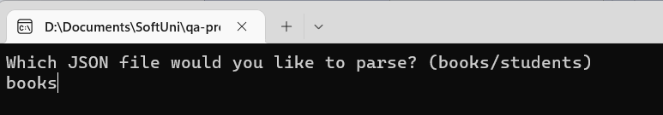
- The parser will process the chosen JSON file and display the extracted data in the console.
- Carefully review the output in the console.
- If the parser displays an error message, check your JSON file for any syntax errors or formatting issues.
- Ensure all required keys are present and correctly named.
- Confirm that your JSON structure aligns with the examples provided in the assignment.

Students

Extract information and create a JSON
You are given a list of 5 students, each described with details like name, age, and a list of courses they are enrolled in. The details are presented in a sentence format:
- "Alice Johnson, 20 years old, is enrolled in Introduction to Computer Science and Web Development."
- "Brian Smith, 22 years old, takes courses in Machine Learning, Artificial Intelligence, Computational Theory, and Robotics."
- "Charlotte Brown, 19 years old, studies Graphic Design and Digital Marketing."
- "David Wilson, 21 years old, focuses on Cybersecurity, Network Infrastructure, Cloud Computing, and Data Privacy."
- "Ella Davis, 23 years old, is pursuing Advanced Mathematics and Quantum Mechanics."
Each student has the following attributes: name (string), age (int), courses (list of courses);
Each course has a name (string).
Convert the list of students' data into a structured JSON format manually:
- Use a text or code editor to create your JSON document. We recommend using Notepad++ or Visual Studio Code for better formatting and syntax highlighting.
- Extract relevant details from each student's description.
- Organize the data into a structured JSON format:
- Each student should be a separate object within an array.
- Include the following keys: name, age, courses.
- Each course should be represented as an object with key: name, within the courses array.
Example:
Students.json
[
{
"name": "Alice Johnson",
"age": 20,
"courses": [
{"name": "Introduction to Computer Science"},
{"name": "Web Development"}
]
},
{
"name": "Brian Smith",
"age": 22,
"courses": [
{"name": "Machine Learning"},
{"name": "Artificial Intelligence"},
{"name": "Computational Theory"},
{"name": "Robotics"}
]
}
... other students ...
]

Use the Provided JSON Parser to Parse the Students
Using the same parser application. Parse and validate the JSON data you have created.
- Open the parser application using Visual Studio. This application is pre-configured to read JSON files from a specific directory.
- Within the parser project, locate the Datasets folder. You will find an empty Students.json file here.
- Open the existing Students.json file.
- Replace the contents of Students.json with the JSON data you created.
- After pasting your JSON data into the corresponding JSON file, make sure to save any changes.
- Run the parser application within your IDE.
- The application will ask you which file you would like to use. Type students.
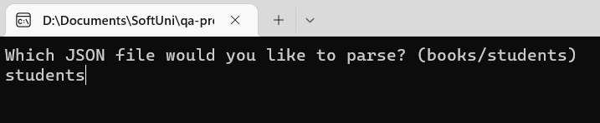
- The parser will process the chosen JSON file and display the extracted data in the console.
- Carefully review the output in the console.
- If the parser displays an error message, check your JSON file for any syntax errors or formatting issues.
- Ensure all required keys are present and correctly named.
- Confirm that your JSON structure aligns with the examples provided in the assignment.

YAML

Orders

Extract information and create a YAML file
You are given a table of six orders, each with order_id (int), customer (string), item (string), quantity (int), and total_amount (float).
Order ID | Customer | Item | Quantity | Total Amount
1001 | John Doe | Wireless Mouse | 3 | 29.97
1002 | Emily Clark | 16GB USB Drives | 2 | 31.96
1003 | Alex Johnson | External Hard Drive | 1 | 89.99
1004 | Sarah Smith | Smartphone Cases | 4 | 39.96
1005 | Michael Lee | Digital Camera | 1 | 120.50
1006 | Karen Thompson | Bluetooth Speakers | 2 | 58.00
Convert the table of orders data into a structured YAML format manually:
- Use a text or a code editor to write the YAML. We recommend Notepad++ or Visual Studio Code.
- Extract relevant details from each order's description.
- Organize the data into a structured YAML format. Each order should be a separate entry in the list.
- Include keys: order_id, customer, item, quantity, and total_amount.
Example:
Orders.yaml
- order_id: 1001
customer: John Doe
item: Wireless Mouse
quantity: 3
total_amount: 29.97
- order_id: 1002
customer: Emily Clark
#continue with the rest

Parse the Orders from YAML to HTML
You are provided with YAML to HTML parser application. Parse and validate the YAML data you have created.
- Open the parser application using Visual Studio. This application is pre-configured to read YAML files from a specific directory.
- Within the parser project, locate the Datasets folder. You will find the empty Orders.yaml file here.
- Open the existing Orders.yaml file.
- Replace the content of Orders.yaml with the YAML data that you created.
- After pasting your YAML data into the corresponding YAML file, make sure to save any changes.
- Run the parser application within your IDE.
- The application will ask you which file you would like to use. Type orders.
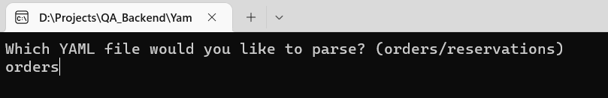
- The parser will process the chosen YAML file and display the extracted data in your default browser.
* If asked if you're allowing to open the output in the browser, choose yes.
- If the parser displays an error message, check your YAML file for any syntax errors or formatting issues.
- Ensure all required keys are present and correctly named.
- Confirm that your YAML structure aligns with the examples provided in the assignment.
- Carefully review the output in the browser.

Reservations

Extract information and create a YAML file
You are given a table of 5 reservations, each with reservation_id, guest_name, and list of services. Each service has type, date and time.
Each reservation has reservation_id (int), guest_name (string), list of services.
Each service has type (string), date (string), time (string)
Reservation ID | Guest Name | Services
101 | Emma Johnson | Spa  June 15th  2 PM  Dinner  June 16th  8 PM
102 | John Davis | Golf  June 17th  10 AM  Wine Tasting  June 18th  5 PM
103 | Sophia Lee | Yoga Class  June 19th  8 AM  Brunch  June 20th  11 AM
104 | Michael Brown | Cooking Workshop  June 21st  4 PM  Movie Night  June 22nd  9 PM
105 | Olivia Smith | Deep Sea Fishing  June 23rd  7 AM  Evening Cruise  June 24th  6 PM
Convert the list of reservations data into a structured YAML format manually:
- Use a text or a code editor to write the YAML. We recommend Notepad++ or Visual Studio Code.
- Extract relevant details from each reservation's description.
- Organize the data into a structured YAML format. Each reservation should be a separate entry
in the list.
- Include keys: reservation_id, guest_name, and services.
- Each service should be represented as an object within the services array.
- Each service has the following keys: type, date, time
Example:
Reservations.yaml
- reservation_id: 101
guest_name: Emma Johnson
services:
- type: Spa
date: June 15
time: 2 PM
- type: Dinner
date: June 16
time: 8 PM
- reservation_id: 102
guest_name: John Davis
#continue with the rest

Parse the Reservations from YAML to HTML
Using the same YAML to HTML parser application. Parse and validate the YAML data you have created.
- Open the parser application using Visual Studio. This application is pre-configured to read YAML files from a specific directory.
- Within the parser project, locate the Datasets folder. You will find the empty Reservations.yaml file here.
- Open the existing Reservations.yaml.
- Replace the content of Reservations.yaml with the YAML data you created. Be sure to overwrite any existing content if the files are not empty.
- After pasting your YAML data into the corresponding YAML file, make sure to save any changes.
- Run the parser application within your IDE.
- The application will ask you which file you would like to use. Type reservations.
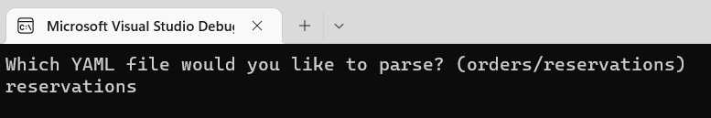
- The parser will process the chosen YAML file and display the extracted data in your default browser.
* If asked if you’re allowing to open the output in the browser, choose yes.
- If the parser displays an error message, check your JSON file for any syntax errors or formatting issues.
- Ensure all required keys are present and correctly named.
- Confirm that your YAML structure aligns with the examples provided in the assignment.
- Carefully review the output in the browser.

XML

Devices

Extract information and create an XML
You are given a table with five devices, each with type, brand, specs, and price.
Type | Brand | Specs | Price
Laptop | Dell XPS 13 | 13.4-inch display | 1200
Smartphone | Apple iPhone 12 | 64GB storage | 799
Tablet | Samsung Galaxy Tab S7 | 11-inch screen | 650
Headphones | Bose QuietComfort 35 II | Noise-cancelling | 299
Camera | Canon EOS Rebel T7 DSLR | 24.1 MP | 449
Convert the list of orders data into a structured XML format manually:
- Write the XML document using a text or a code editor. We recommend using Notepad++ or Visual Studio Code for better formatting and syntax highlighting.
- Carefully read each device's description and identify key information. You should extract the
following details:
- Type of device (e.g., Laptop, Smartphone)
- Brand (e.g., Dell XPS 13, Apple iPhone 12)
- Specs (e.g., screen size, processor, storage)
- Price
- Create an XML document where each device is represented as a separate entry. Structure your XML with appropriate tags.

Example:
Devices.xml
<devices>
<device>
<type>Laptop</type>
<brand>Dell XPS 13</brand>
<specs>13.4-inch display </specs>
<price>200</price>
</device>
<!-- More device entries here -->
</devices>

Parse Devices from XML to JSON
You are provided with XML to JSON parser. Parse and validate the XML data you have created.
- Open the parser application using Visual Studio. This application is pre-configured to read XML documents from a specific directory.
- Within the parser project, locate the Datasets folder. You will find an empty Devices.xml file here.
- Open the existing Devices.xml.
- Replace the content of Devices.xml with the XML data you created.
- After pasting your XML data into the corresponding XML file, make sure to save any changes.
- Run the parser application within your IDE.
- The application will ask you which file you would like to use. Type devices.
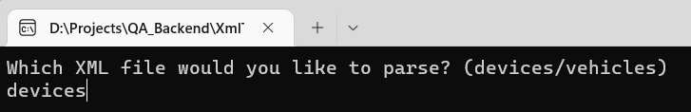
- The parser will process the chosen XML file and display the extracted data in JSON format on the console.
- If the parser displays an error message, check your XML for any syntax errors or formatting issues.
- Ensure the required XML structure and the appropriate tags.
- Confirm that your XML structure aligns with the examples provided in the assignment.
- Carefully review the output in the console.

Vehicles

Extract information and create an XML
You are given a list of five vehicles, each with type, model, specs, and color.
- "Car: Tesla Model 3; Electric sedan; red"
- "Motorcycle: Harley-Davidson; V-twin engine; black"
- "Bicycle: Giant Escape 3; Aluminum frame; black"
- "Scooter: Vespa Primavera; 50cc engine; white"
- "Boat: Bayliner Element; 18-foot length; black"
Convert the list of orders data into a structured XML format manually:
- Write the XML document using a text or a code editor. We recommend using Notepad++ or Visual Studio Code for better formatting and syntax highlighting.
- Carefully read each device's description and identify key information. You should extract the
following details:
- Type (e.g., Car, Bicycle)
- Model (e.g., Harley-Davidson)
- Specs (e.g., Electric sedan)
- Color (e.g., red)
- Create an XML document where each device is represented as a separate entry. Structure your XML with appropriate tags.

Example:
Vehicles.xml
<vehicles>
<vehicle>
<type>Car</type>
<model>Tesla Model 3</model>
<specs>Electric sedan</specs>
<color>red</color>
</vehicle>
<!-- More vehicle entries here -->
</vehicles>

Parse the Vehicles from XML to JSON
Using the same XML to JSON parser. Parse and validate the XML data you have created.
- Open the parser application using Visual Studio. This application is pre-configured to read XML documents from a specific directory.
- Within the parser project, locate the Datasets folder. You will find Vehicles.xml file here.
- Open the existing Vehicles.xml file.
- Replace the content of Vehicles.xml with the XML data you created.
- After pasting your XML data into the corresponding XML file, make sure to save any changes.
- Run the parser application within your IDE.
- The application will ask you which file you would like to use. Type vehicles.
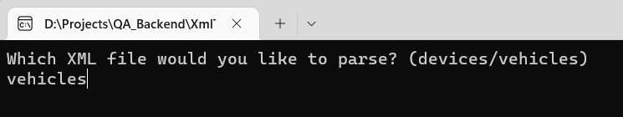
- The parser will process the chosen XML file and display the extracted data in JSON format on the console.
- If the parser displays an error message, check your XML for any syntax errors or formatting issues.
- Ensure the required XML structure and the appropriate tags.
- Confirm that your XML structure aligns with the examples provided in the assignment.
- Carefully review the output in the console.

